CCNA: Introduction to Network

**Module 4 – 4.4: UTP Cabling**

**A. Properties of UTP Cabling**

- UTP (Unshielded Twisted-Pair) cabling is the standard for LANs. It consists of four pairs of twisted copper wires in a plastic sheath. Its small size is good for installation. Instead of shielding, UTP cable uses:

* Cancellation (Triệt Tiêu): Paired wires create opposing magnetic fields that cancel each other out, including external EMI/RFI.
* Varying Twists (Độ xoắn khác nhau): Different twist rates per pair enhances cancellation. Specific twist numbers are mandated.

- UTP relies solely on these twisted-pair cancellations for self-shielding and limiting signal degradation

**B. UTP Cabling Standards and Connectors**

UTP cabling standards are defined by TIA/EIA-568, covering cable types, lengths, connectors, termination, and testing. IEEE defines the electrical characteristics and categorizes cables (Cat3, Cat5, Cat5e, Cat6, Cat6a, Cat7, Cat8) based on bandwidth support. Higher categories support faster speeds. Cat5e is now the minimum, and Cat6 is recommended for new installations. Key categories and speeds:

* Cat5e: 1 Gbps
* Cat6: 10 Gbps
* Cat6a/7: 10 Gbps
* Cat8: 40 Gbps

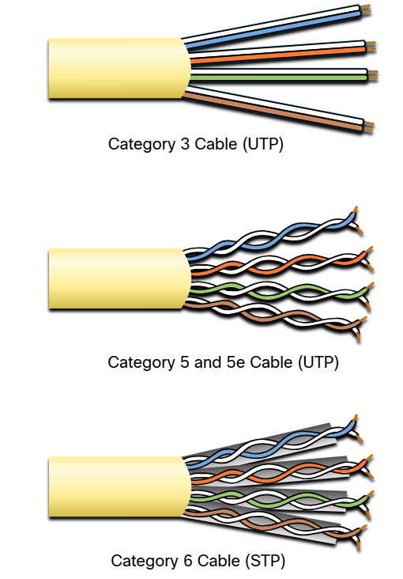

- RJ-45 connectors are used to terminate UTP cables. Proper termination is crucial for network performance. A good termination involves:

* Wires untwisted only as much as necessary.
* Cable jacket extending into the connector for secure crimping.
* All eight wires reaching the end of the connector.

=> Improper termination (like exposed or excessively untwisted wires) can significantly degrade signal quality and network performance.

**C. Straight-through and Crossover UTP Cables**

- UTP cables are wired differently for different purposes. The two main types are:

* Straight-through: Used to connect dissimilar devices (e.g., host to switch, switch to router). This is the most common type.
* Crossover: Used to connect similar devices (e.g., switch to switch, host to host). These are becoming obsolete due to Auto-MDIX.

- Using the wrong cable type (straight-through where a crossover is needed, or vice-versa) will prevent communication. Auto-MDIX eliminates the need for crossover cables in most modern setups. There is also a less common "rollover" cable used for Cisco console ports. The T568A and T568B standards define the specific wiring of these cables.

- T568A: xanh lá sọc trằng, xanh, cam sọc trắng, xanh dương, xanh dương sọc trắng, xanh lá cây, nâu sọc trắng, nâu.

- T568B: cam sọc trắng, cam, xanh lá sọc trắng, xanh dương sọc trắng, xanh dương, xanh lá, nâu sọc trắng, nâu